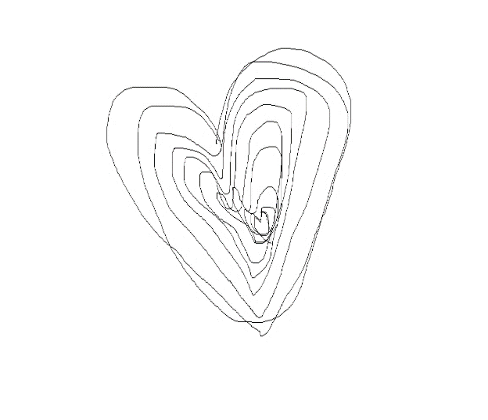

Abstract submission

the conference The Figurativeness of the Language of Mystical Experience
Particularities and Interpretations
29 – 30 June 2021

Author’s name and surname, academic degree(s)
Name of institution
Contact e-mail
Title of the paper
Abstract (max. 1200 characters)
Key words

